Module – 3 Assignments
Advanced SQL

Mandatory Hands-on: -
Exercise 1: Ranking and Window Functions
Scenario:
A company maintains employee salary information across multiple departments. The management wants to analyse employee salaries by assigning a rank within each department based on salary. SQL Window Functions such as RANK() make it possible to perform ranking without grouping the data, allowing each employee's record to remain visible while calculating the rank. This helps management identify the highest-paid employees in each department and compare employee performance based on salary.
Procedure:
- Open the SQL Server Management Studio (SSMS) or MySQL Workbench.
- Create the Employee table with the required columns.
- Insert sample employee records into the table.
- Use the RANK() window function with the OVER() clause.
- Partition the data by department and order salaries in descending order.
- Execute the SQL query.
- Verify that employees are ranked correctly within their respective departments.
Code:
CREATE DATABASE IF NOT EXISTS cognizant;
USE cognizant;
DROP TABLE IF EXISTS Employee;
CREATE TABLE Employee(
EmpID INT PRIMARY KEY,
EmpName VARCHAR(50),
Department VARCHAR(30),
Salary INT
);
INSERT INTO Employee VALUES
(101,'Amit','HR',45000),
(102,'Ravi','HR',55000),
(103,'John','IT',70000),
(104,'David','IT',65000),
(105,'Priya','Sales',50000);
SELECT * FROM Employee;
Output:
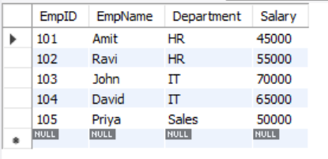
Code:
USE cognizant;
SELECT
EmpID,
EmpName,
Department,
Salary,
RANK() OVER(PARTITION BY Department ORDER BY Salary DESC) AS Rank_No
FROM Employee;
Output:
